Session 10 – SMAC Wei Cui

**Lab Objectives**

* Follow the instructions for Project 9-2 Substitute a MAC Address Using SMAC
* Write a report including screenshots and written descriptions. Be sure to include a screenshot and description for step 9.

**Lab Results**

1. Went to [www.klcconsulting.net/smac](http://www.klcconsulting.net/smac) (Fig 1)
2. Scrolled down to FREE Download – SMAC 2.0
3. Clicked on Download Site 3 (Fig 2)
4. The file finished downloading, however, it was not able to run and complete the installation procedures. Fig 3 shows Windows prevents SMAC from running. Fig 4 shows SMAC exe is corrupted.
5. I copied the SMAC exe to an old laptop which has Windows XP installed, but the exe is unable to run either.
6. If SMAC is installed successfully, we can modify MAC address of a NIC by following the lab instructions.
7. SMAC is a MAC address modifier. One of the benefits of changing a MAC address is security. There are security breaches than rely on getting the MAC address of a machine. Changing the MAC address frequently can add another layer of security.
8. Did some research over the weekend and found SMAC installer from <http://download.cnet.com/SMAC-MAC-Address-Changer/3001-2085_4-10536535.html>
9. SMAC displays the network interface card adapters as shown in Fig 5.
10. Clicked on each adapter, the Active MAC address changes. There are two network adapters: 1) Intel Wireless Adapter installed on my laptop, and 2) Dummy network card, loopback adapter for testing. Each adapter has its own MAC address.
11. Clicked on a network adapter and clicked Random button to change the MAC address. It is displayed in the new Spoofed MAC address
12. Clicked Random button to create a new MAC address: 00-10-B9-7A-3C-3D for the Loopback Adapter which has an Active MAC address of 02-00-4C-4F-4F-50 (Fig 6)

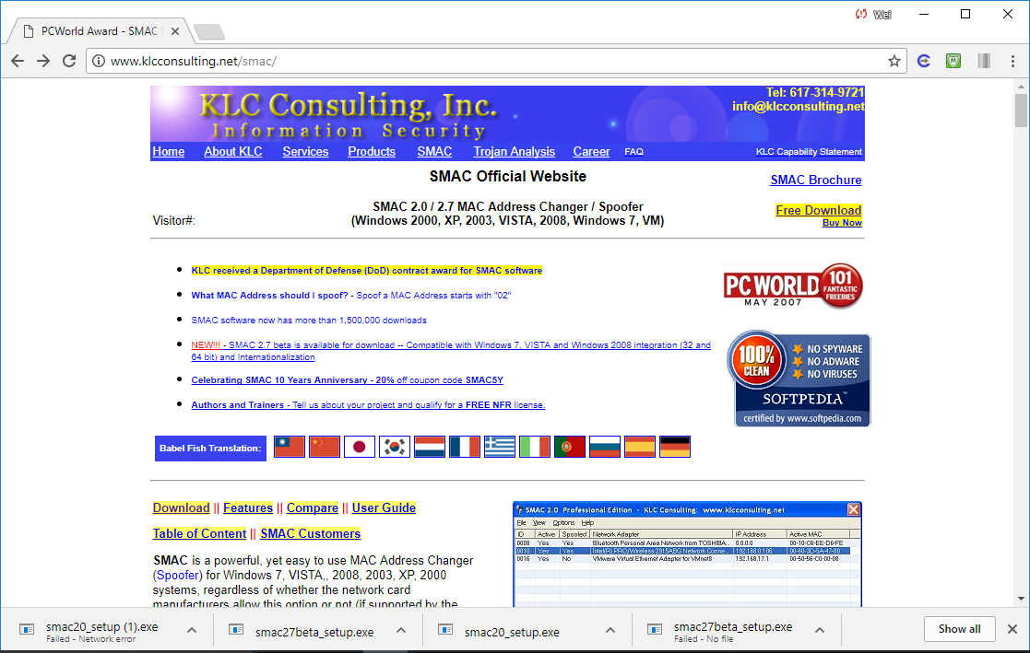

Fig. 1. SMAC Official Website: www.klconsulting.net/smac

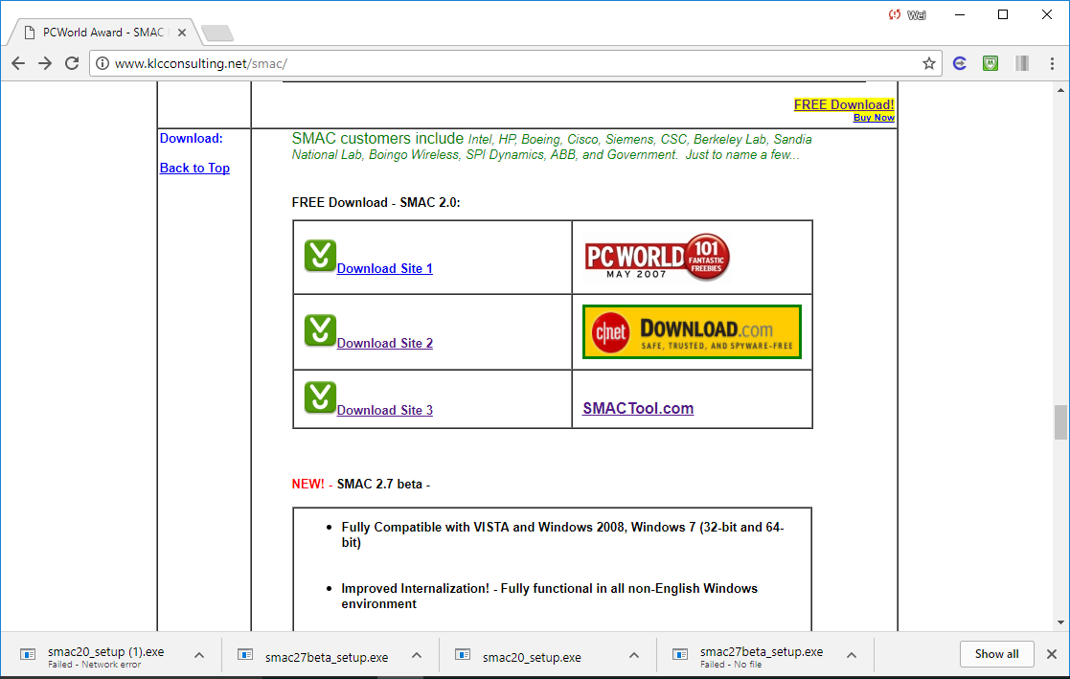

Fig. 2. SMAC Official Website: www.klconsulting.net/smac

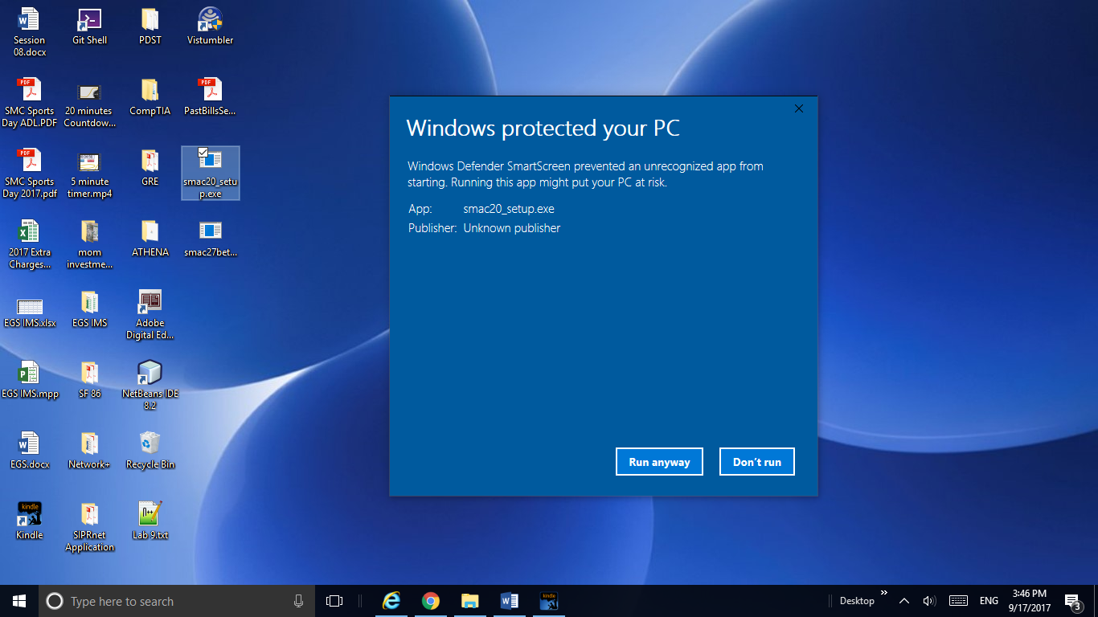

Fig. 3. Windows Defender prevented SMAC from starting

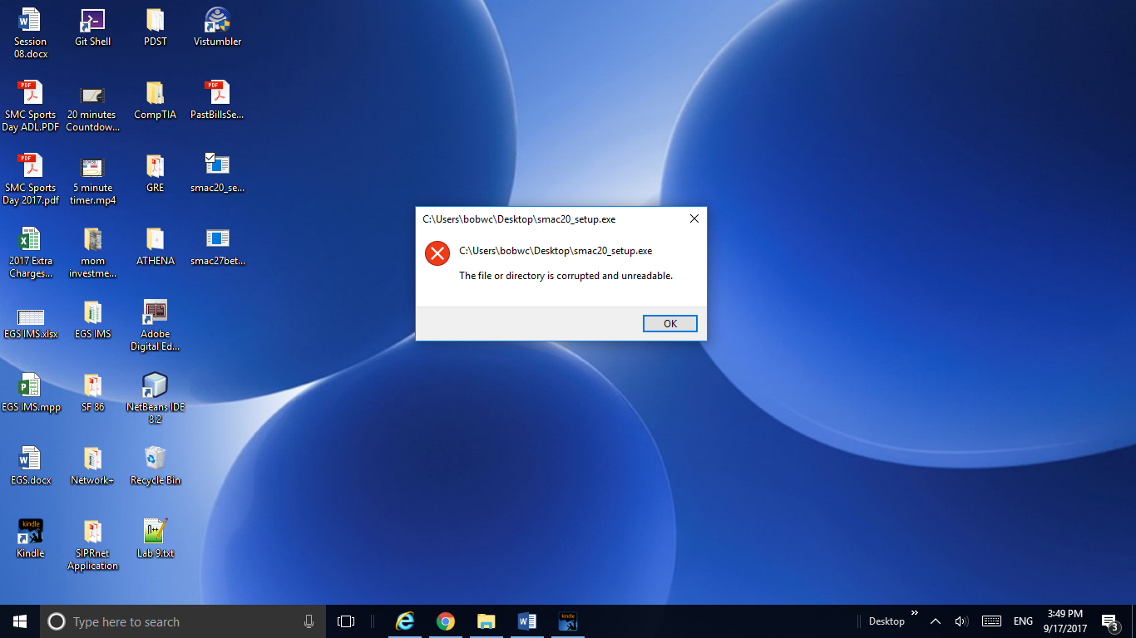

Fig. 4. SMAC setup exe is corrupted and unreadable.

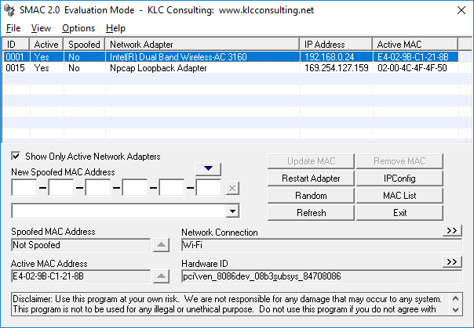

Fig.5 SMAC main window

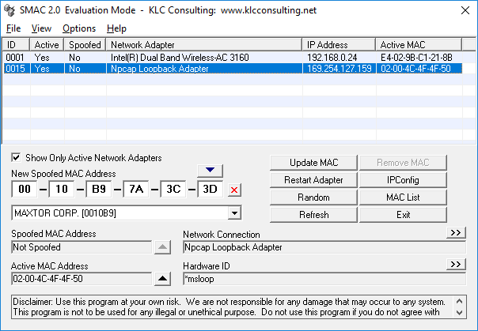

Fig.6 Created a New Spoofed MAC address: 00-10-B9-7A-3C-3D for the Loopback Adapter which has an Active MAC address of 02-00-4C-4F-4F-50